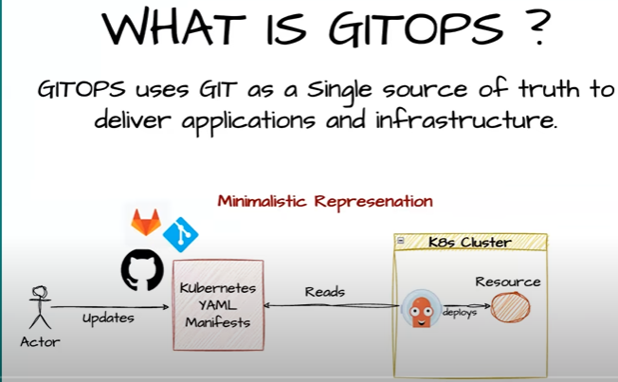
Gitops is solving the problem were u don’t have a track at the deployment side.
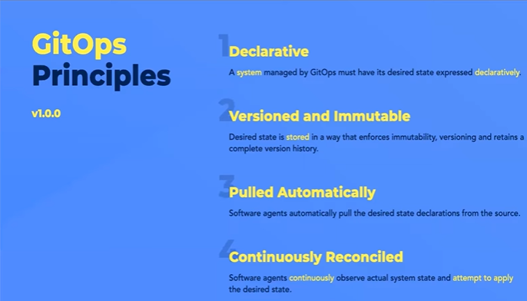
If u want to make any change to the resource that gitops controller is managing then u have to first change that into a git repository then only the change will be deployed by me I.e,gitops controller
If any unwanted change has been made in resource by some hacker or anyone gitops controller will takecare of it. Giops will keep a track on all resources as cache it has a read access to k8s cluster or any resource to get info.
Gitops observes both the states i.e, in git and deployment if any change find it will overwrite it
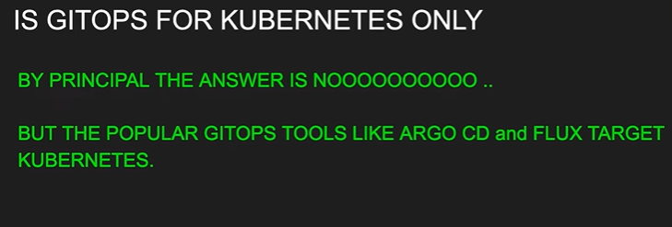
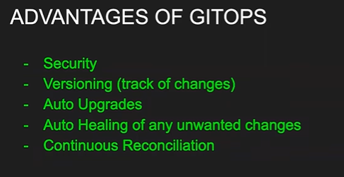
Gitops means not only git as any version control system we can use like s3
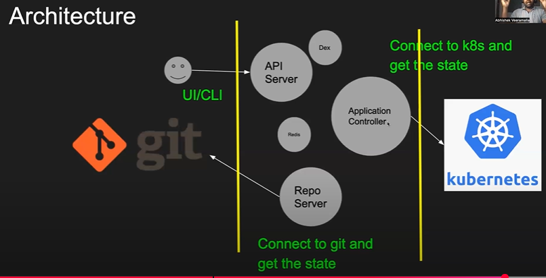
Repo server: which is talking to git
Application controller: which is gtg updates from the k8s
This controller will get the info from the repo server try to compare it with the git and k8s is same or not
Api server: that is used as a ui or cli authentication .
Dex: which adds the sso capabilities like oidc,oauth related config.
Redis: these apps are statefull sets so they have to cache the info
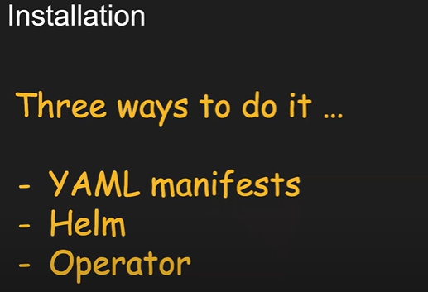
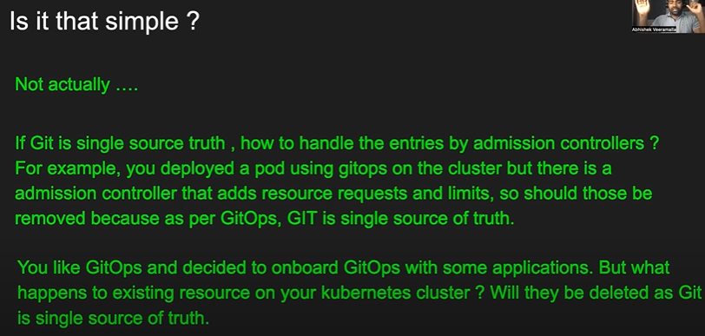
Argocd deployment:
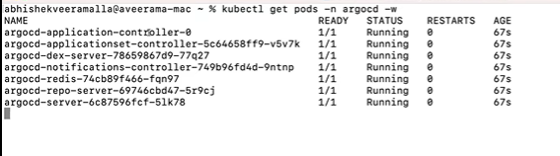
By default it argocd comes with the cluster ip mode
To get the paasswrd from secret
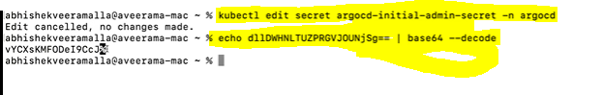
Argo cd ui:
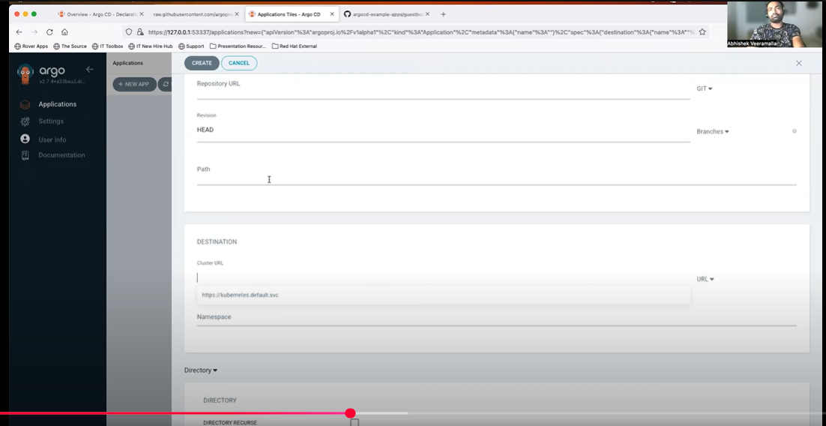
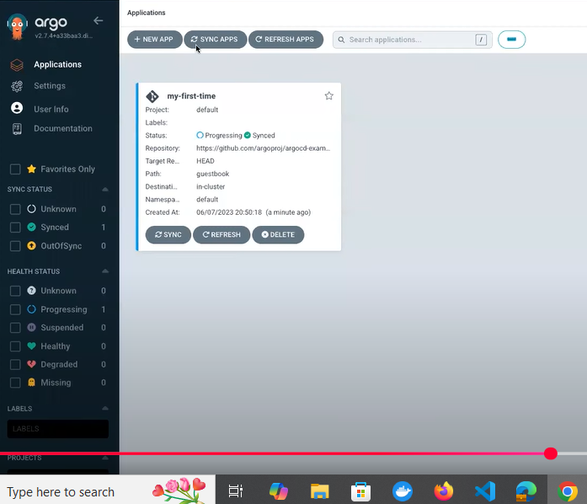
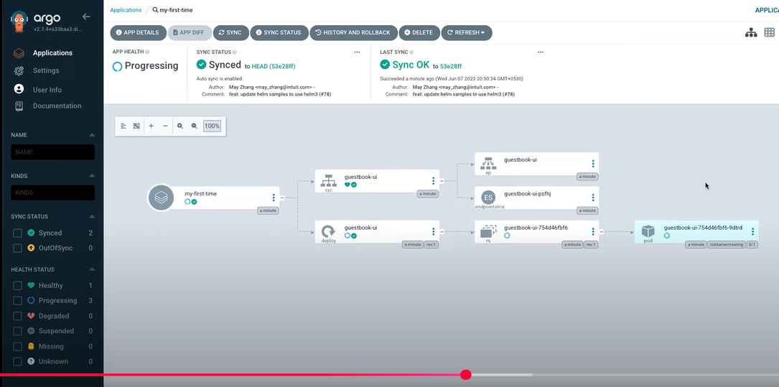
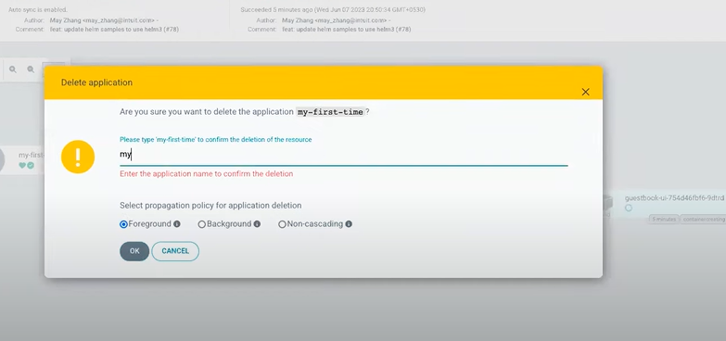
If an applications is launched in one of the nodeports in many nodes u can access the app fro any node not only that node
Through argo cd cli u can deploy or add multiple clusters but through it is difficult
To do that :
Install argocd cli
Then run below cmd
Kubectl config get-contexts | grep us-west-1
After running the above cmd u will get contexts for all the clusters deployed
Then run
Argocd add cluster and the cluster context id then the instanceip and port
To run the above cmd u have to first login to the argocd cli
Argocd login argocd api address
Auto sync happens every 3mins in argocd
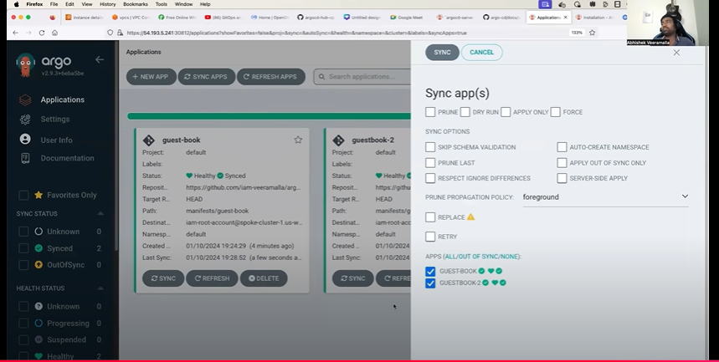
This is how argocd notify u when something went wrong

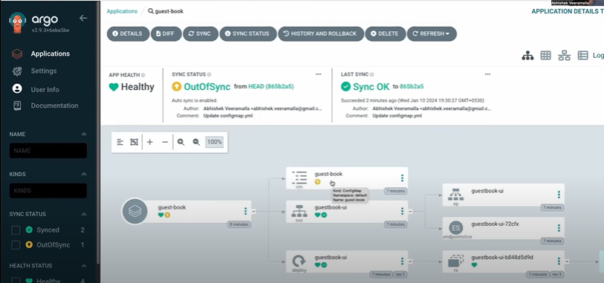
https://razorops.com/blog/top-50-argocd-interview-questions-and-answers/

